𝜏 = Space time, time required to react to one unit volume = V/v0 = V/(FA0/CA0)

1/𝜏 = space velocity, reactor volumes able to react per unit time

**Mean Residence Time**

**Ideal Steady-State MFR**

* Uniform Composition
* Contents of reactor = contents of exit flow
* In - Out - Disappearance by Reaction = 0
* FA0 = FA0(1-XA) - rV

FA0XA = -rAV

V/FA0 = XA/-rA

V/v0CA0 = XA/-rA

𝜏/CA0 = XA/-rA

𝜏 = CA0 - CA / -rA

Zero order: k𝜏 = CA0 - CA

First order: k𝜏 = CA0 - CA / CA

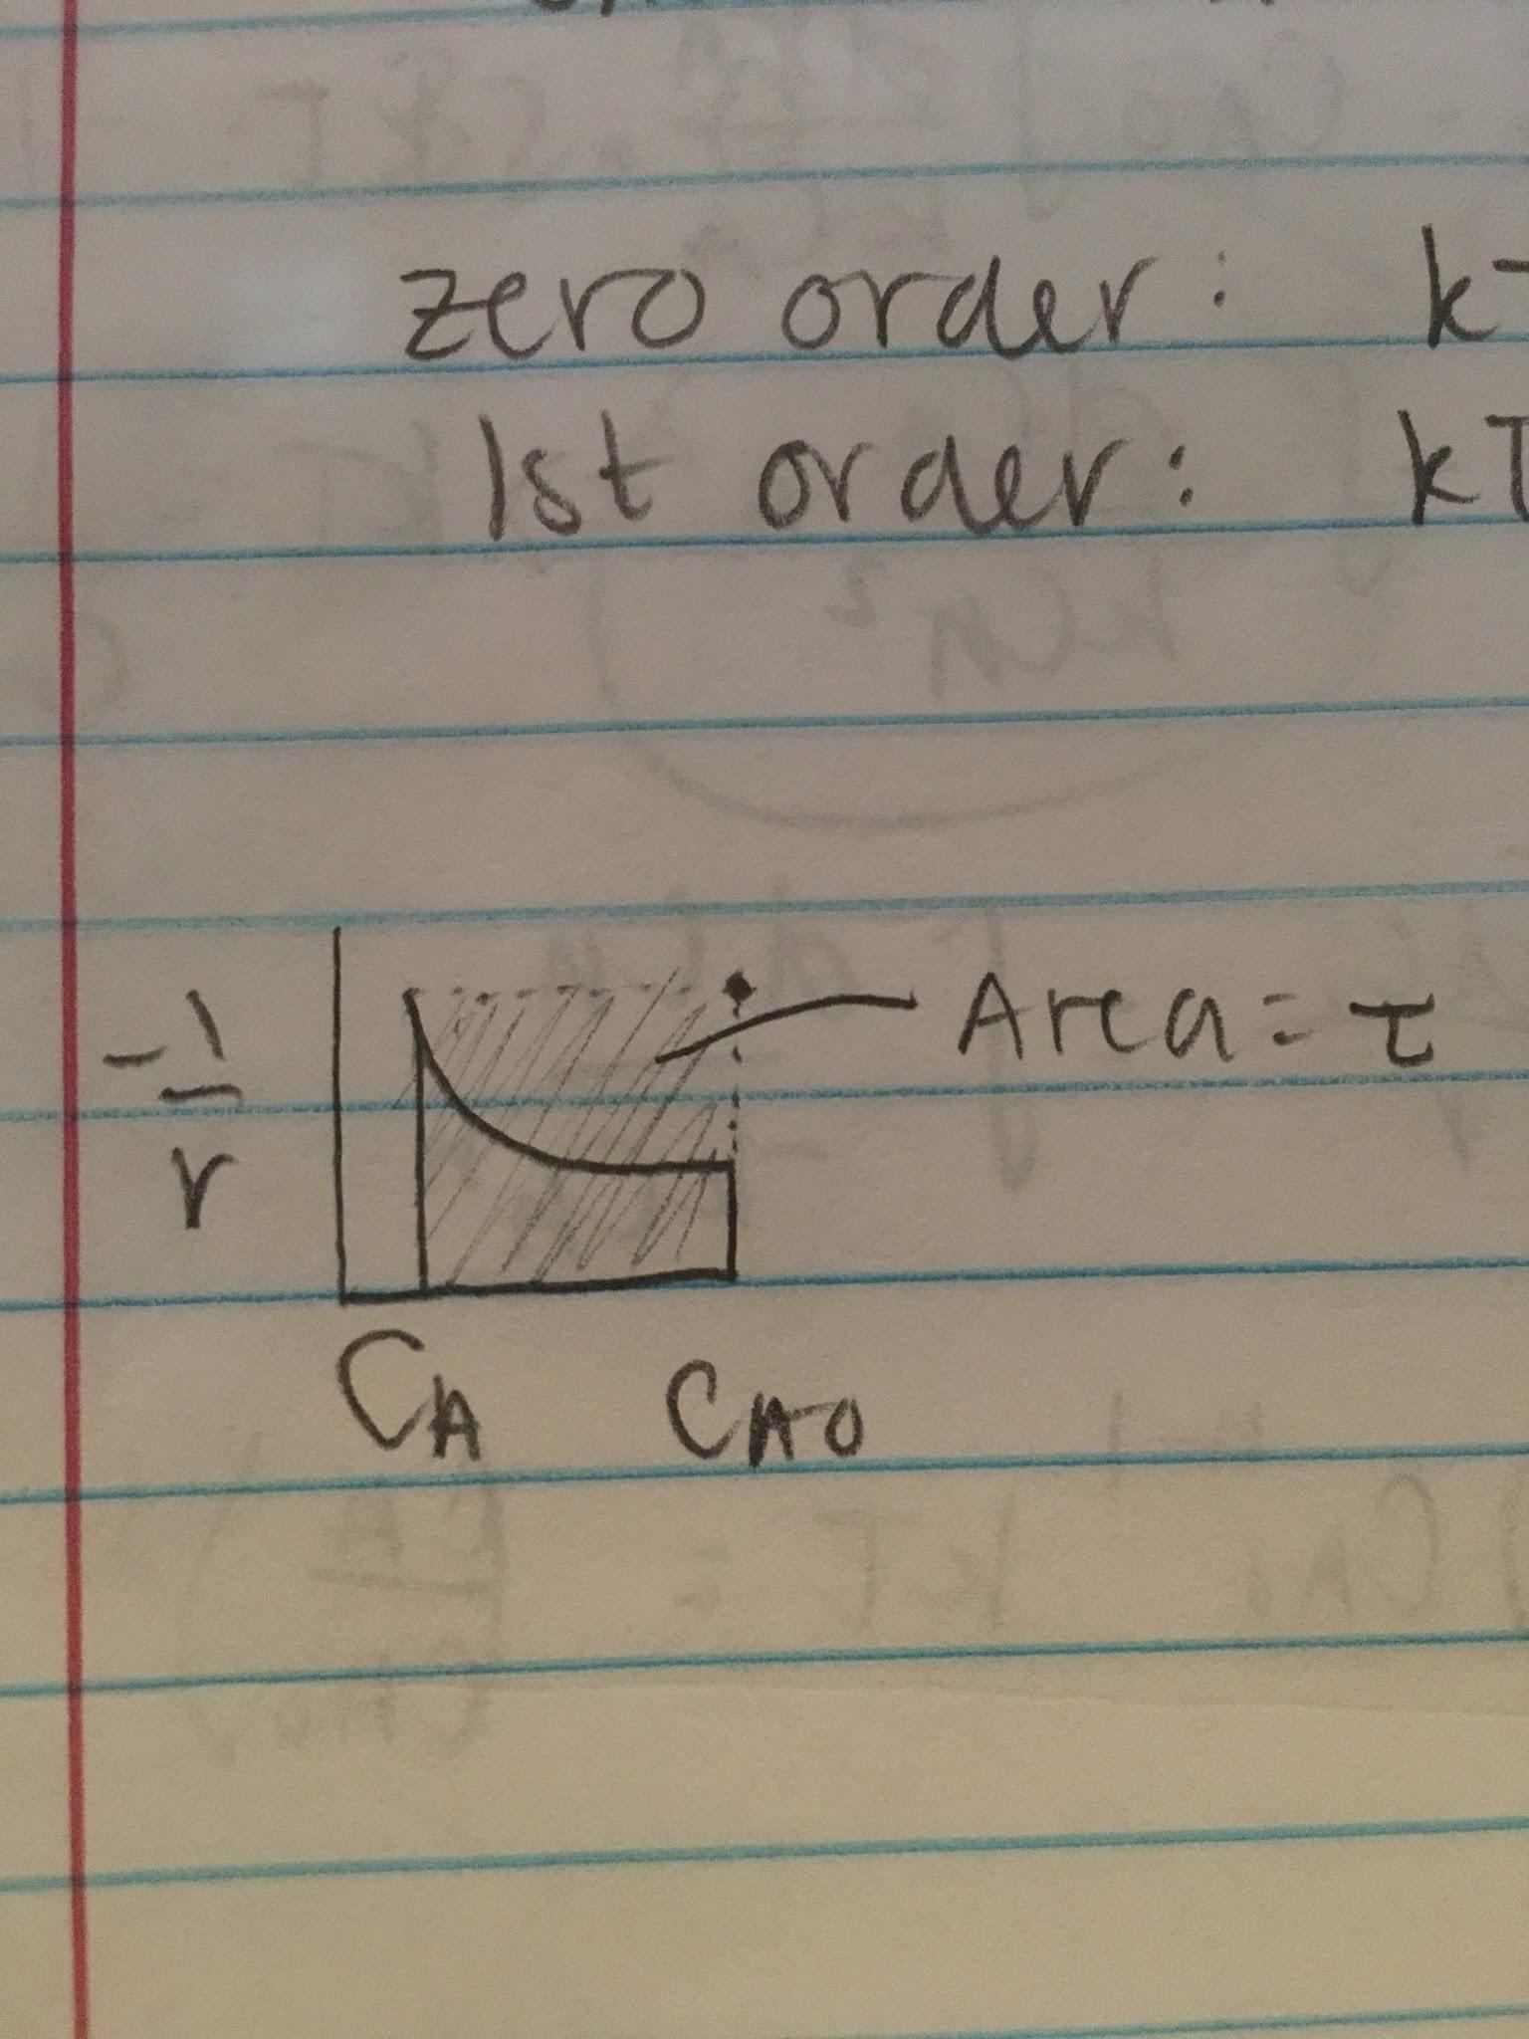

V = 35 L

v0 = 1 L/min

𝜏 = 35 L / 1 L/min = 35 min

CA = 12 mg/L

𝜏 = CA0-CA/-r = CA0-CA/kC2

CA0 = 𝜏kCA2 + CA = 35 min * 0.015 L/min.mg * 12 mg/L + 12 mg/L = 87.6 mg/L

**Ideal Plug Flow Reactor**

* As reaction rate increases, productivity and conversion increase

dFA = -FA0 dXA

FA0dXA = -rAdV

𝜏 = ∫ dCA/-r

𝜏/CA0 = ∫dXA/-rA

* Zero order: 𝜏 = ∫dCA/-k
  + k𝜏 = CA0XA
* First order: 𝜏 = ∫dXA/kCA
  + k𝜏 = -ln(CA/CA0)
* Second order: 𝜏 = -∫dCA/kCA2
  + k𝜏 = 1/CA - 1/CA0
* Nth order: 𝜏 = ∫dCA/r = ∫dCA/-kCAn
  + (n-1)CA0n-1k𝜏 = (CA/CA0)1-n-1

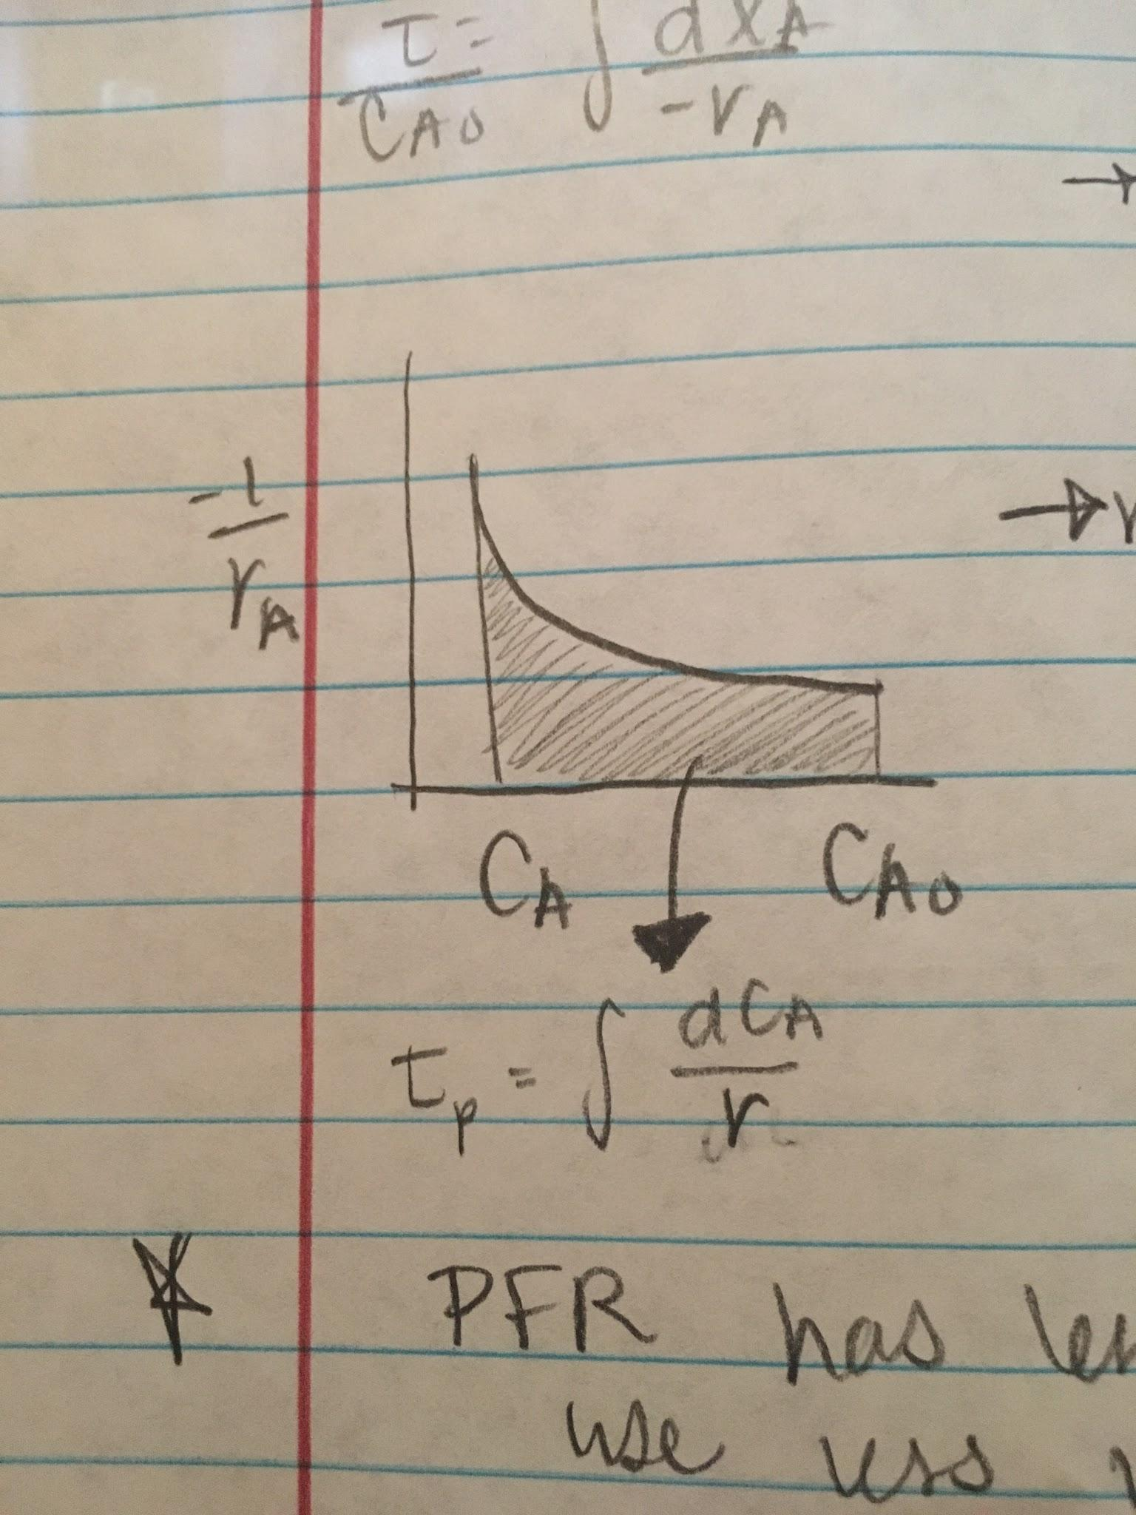

PFR has less spacetime, more efficient

Use less volume to get same reaction

**Performance Equations**

Batch: t = ∫dC/r

Mixed Flow: 𝜏m = C0-C/-r

Plug Flow: 𝜏p = ∫dC/r

Equations give ideal reactor performance

**PFR Example**

120 L = V

15 L/min = v0

28 mol/L = CA0

4.7 L/mol*min = k (second order)

Outlet Concentration?

4.7 L/mol*min * 120 L / 15L/min = 1/CA - 1/28 mol/L

32 = 1/CA - 0.0357

32.0357 = 1/CA

CA = 0.0312 mol/L